Individual Project – Home Repossessions in London

Introduction & Motivation

Research Question: ‘*How much did financial events contribute to the home repossessions in London?*’

Housing has been an issue which has been ever-present within modern society, with many homeless people having to suffer harsh conditions whilst there are homes empty within cities in the UK. Especially with the recent General Election, and pledges to build and rehouse people, I wanted to see how bad the problem really is, and look into potential reasons as to why people were forced into homelessness. Specifically, I wanted to look at the effect financial events such as the Recession in 2008, as well as the gradual inflation of house prices in the late 20th century to now, and how it has directly caused people to lose their homes within the city of London, whilst also looking at the disparity between the inner and outer boroughs of London.

Dataset & Pre-processing

I used the ‘Mortgage and Landlord Possession Actions, Borough’ dataset available at <https://data.london.gov.uk/dataset/mortgage-and-landlord-possession-actions-borough>. I found the data after browsing through the housing data that the website had. The data was contained in an .xls file, within a pivot table. Due to my inexperience with pivot tables, and not knowing how to use them, I decided to extract the data myself into a .csv file, which I eventually used for my visualisation. This also allowed me to combine all the reasons for the repossessions of homes (some reasons were very specific). This overall made it easier for me to work with the data. Whereas the data contained things such as claims made, I wanted to specifically look at actual instances of people losing their homes to repossessions.

The data was split in the quartiles of the year, and for the new .csv file, I combined all 4 quartiles into a yearly observation. As number of repossessions were counted and were not estimates, I could combine the quarterly counts and set the record to ‘xxxx-12-31’ of that year. I had to melt the columns into rows, so that the data was tidy.

The data was collected from 2003 to 2015, and contained many regions within the UK, including parts of Wales, and regions of England. As I specifically wanted to look at London, I removed the data that was not included in this region. Furthermore, it included parts of London that were not boroughs, such as the City of London. I added the data for those regions into their respective borough. Furthermore, due to 2015 not having 4 complete quartiles, I decided to not use it for the project.

Variables

The variables I used for my visualisations were:

* *Year* – Interval – The year in which the number of repossessions were counted
* *Repossessions* – Interval – The number of homes repossessed within that calendar year
* *Area* – Categorical/Nominal – The name of the borough
* *Location* – Categorical/Nominal – Whether it is an Inner or Outer borough

Findings

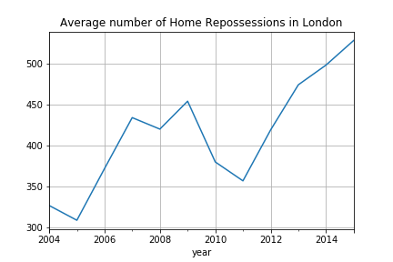

To begin with, I wanted to look at the general average number of home repossessions per year in London, without necessarily focussing on the location of the borough. The y-axis has the average number of homes repossessed, and the x-axis has the year this was recorded.

As you can see, the number of repossessions decreases between 2008 and 2011, due to the factors such as the Recession in 2008, which led to housing prices decreasing. It makes sense that as the price of the homes decrease, less people would be removed from their homes due to repossession. However, from 2011 onwards, the average number of repossessions increased sharply from 2011 onwards, in what was stated as the UK’s ‘worst ever financial crisis’ back then [1].

From this, I wanted to include the location of the boroughs into the visualisation, being able to see the difference between the outer and inner boroughs of London. Here, I collected the total/sum of each year’s repossessions, and listed it by year from 2003 to 2014.

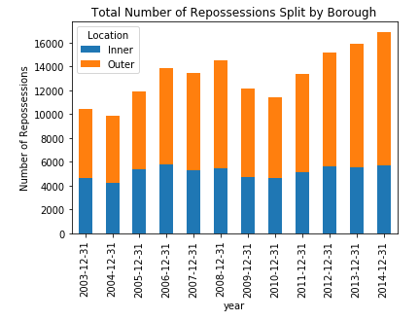

As you can see, the inner boroughs have a considerably lower amount of repossessions than the outer borough annually, with more than half of the annual repossessions of homes occurring in the outer boroughs of London ever year. 2014 has the highest amount of repossessions, more than 16,000 total homes being repossessed in London that calendar year, and over 10,000 alone from the outer boroughs of London, totalling 66% of the repossessions that year.

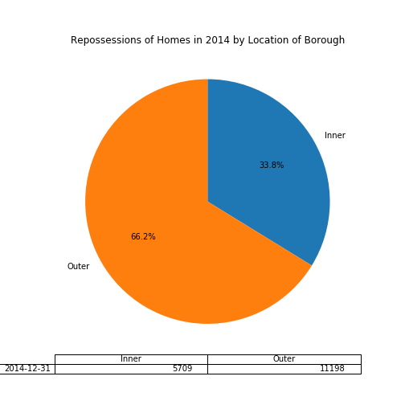

I wanted to look at the individual boroughs that year, and see whether any boroughs in inner London were misrepresented.

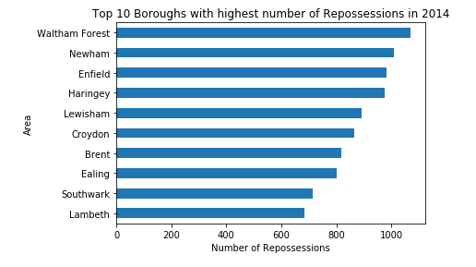

As you can see, majority of the boroughs included are outer. However, Lewisham, Southwark and Lambeth are all inner boroughs. They are also geographically close to each other, located in South London. This is interesting as it shows that even if a borough is in inner London, it can still have a high number of repossessions.

Next, I wanted to look at the year-on-year change in the number of repossessions in the London boroughs.

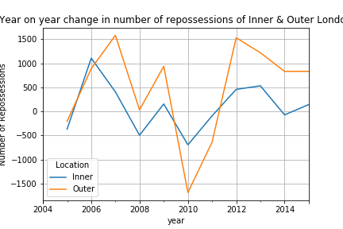

As you can see, the blue inner line oscillates, with some years seeing less repossessions than the previous. However, during the period of 2008-2013, where in previous graphs there was a decline then sharp increase, there is not much change to what is happening to the previous years. The line continues to oscillate slightly, mostly staying around the 0 repossession line,

However, for the orange outer boroughs, you can see that there is an increase of repossessions each year until 2009, where there are massive decreases in repossessions. This is due to people being able to afford their houses as the prices of homes decreased. However, the largest increase ever seen occurs just after 2011, which coincides with the data shown in previous visualisations. There is then an increase in repossessions every year after that.

As the number of repossessions keeps increasing in the outer boroughs, but not necessarily for the inner boroughs, we can see that there is a trend. The endpoint of the data, the year 2014, has the largest difference between the inner and outer boroughs. It would be safe to assume that this trend would not change anytime soon unless the complex issue of housing is dealt with soon.

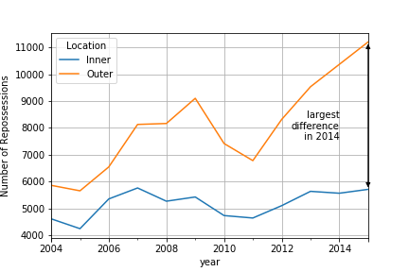

Conclusion

As you can see, the number of homes repossessed coincided with the financial events occurring in the world. The financial crises that occurred in the US and Western Europe definitely influenced the amount of homes repossessed. This is due to the prices of rent/owning a home directly being affected, and even though there was a period where homes were slightly cheaper and more people could afford them, it was not due to a sustainable resolution, meaning that the prices of homes bounced back. This led to lots of homes being repossessed annually, at an increasing rate as well.

The disparity between the boroughs of London was prevalent, with the majority of repossessions occurring in outer London. These are areas that are not seeing the same financial investments as areas located in inner London. This directly leads to housing issues over time, with more and more people suffering from house repossessions. However, this is not to say that all inner boroughs receive the same treatment. As shown earlier, 3 inner boroughs were in the top 10 boroughs with the most repossessions in the year that the most homes were repossessed.

I believe that the project went well, with the majority of the visualisations being relevant to the topic, and allowing for analysis to be done on them. If I were to do anything different, I would make sure to understand how pivot tables work, as there was a lot of data that I was leaving behind by just extracting the data and putting it into another .csv file.

Bibliography

L. Elliott and K. Allen, "Britain in grip of worst ever financial crisis, Bank of England governor fears", *The Guardian*, 2011 – <https://www.theguardian.com/business/2011/oct/06/britain-financial-crisis-quantitative-easing>

Appendix

1. Repossessions of Homes in the Inner Boroughs of London

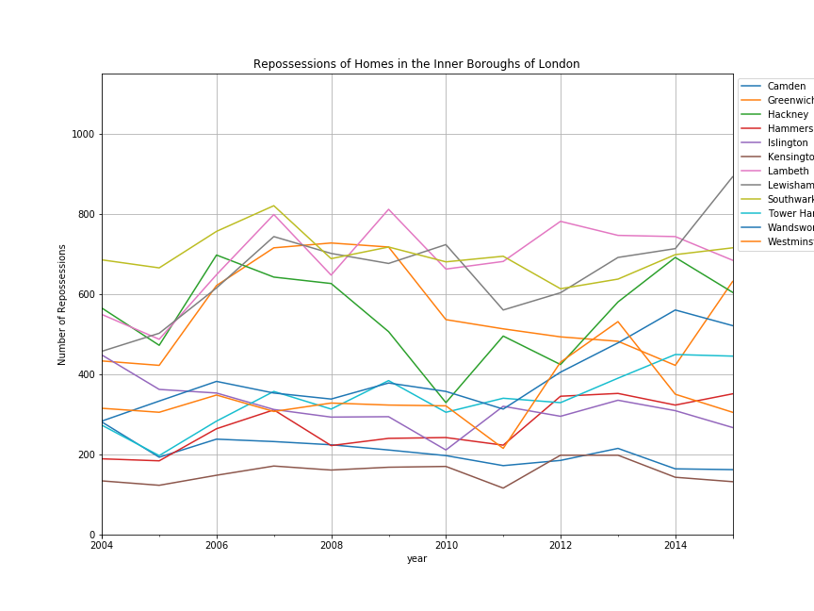

1. Repossessions of Homes in the Outer Boroughs of London

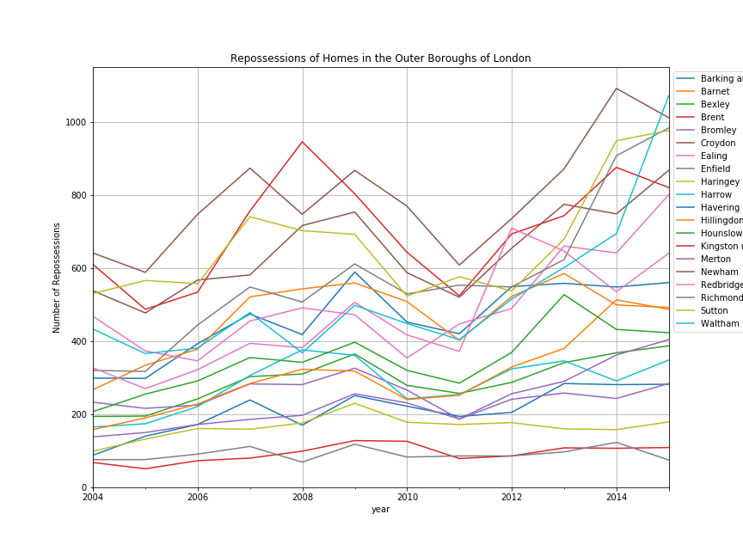

1. Difference of Home Repossessions between Outer & Inner Boroughs

